Global Migration Data Analysis Centre  
Data Briefing Series

IOM*OIM

Issue No. 1, January 2016

Migration, asylum and refugees in Germany:

Understanding the data

During 2015, more than one million migrants and refugees arrived in Germany

Syrians were the largest group of first time asylum applicants, with numbers increasing each month throughout the year. The peak figures were seen in November, when more than 30,000 applications were recorded (see Figure 1). On 9th January 2016, Ole Schroder, Parliamentary State Secretary in the Federal Ministry of the Interior (BMI), referred to a possible one million asylum-seekers coming to Europe during the coming year, mostly through Turkey.1

Frank Jurgen Weise, Head of the Federal Office for Migration and Refugees (BAMF), has estimated that around half that number, 500,000 refugees, will arrive in Germany.2 This briefing aims to present the available official data and to explain some of the differences between the data types.

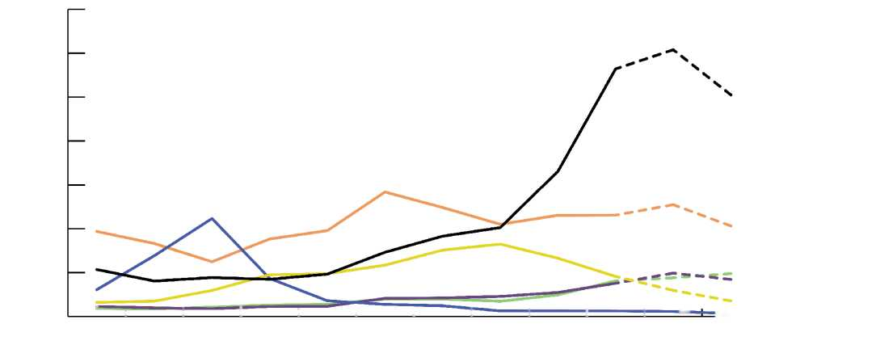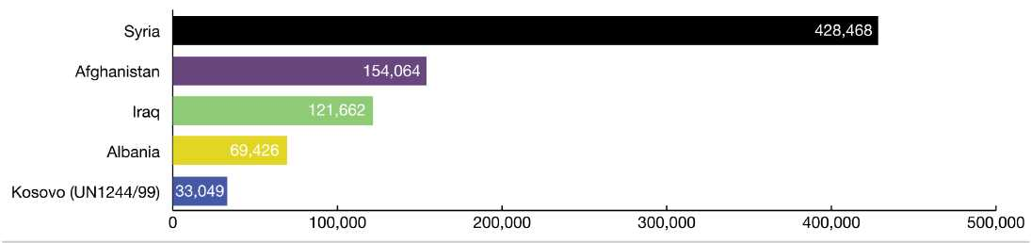

**Figure 1: First time asylum applications in Germany, by main citizenships and month, 20153**

35,000

30,000

25,000

20,000

15,000

10,000

5,000

0

Syrian Arab

Republic

Other countries

Iraq

Afghanistan Albania

= Kosovo (UN 1244/99) Dec

' i I I i i i i i i i —

Jan Feb Mar Apr May Jun July Aug Sep Oct Nov

**Figure 2: Main countries of origin registered in EASY, Jan—Dec 20154**

**Disclaimer:** The opinions expressed in this briefing are those of the authors and do not necessarily reflect the views of the International Organization for Migration (IOM). The designations employed and the presentation of material throughout the briefing do not imply the expression of any opinion whatsoever on the part of IOM concerning the legal status of any country, territory, city or area, or of its authorities, or concerning its fronties or boundaries. Data correct at time of writing (early January 2016) and are subject to change following publication. **Editors:** Frank Laczko (Head of GMDAC) and Ann Singleton (on secondment to GMDAC, University of Bristol). **Authors:** Ann Singleton (on secondment to GMDAC, University of Bristol), Adrian Carrasco Heiermann (Consultant, GMDAC), and Denis Kierans (Data and Research Officer, GMDAC). Notes: (1) Der Spiegel (2016) <http://www.spiegel.de/politik/deutschland/bundesregierung-> sieht-kein-ende-der-fluechtlingskrise-a-1071136.html.

Arrivals

Record monthly inflows during 2015, with peaks in October and November, resulted in 1,091,894 registrations in the German EASY system, which records those who **intend to apply** for asylum.5

The EASY system collects two variables, "the receiving German state" and "country of origin" but not data on the profile of asylum-seekers and refugees.

Of those registered in EASY between January and the end of December 2015, the main countries of origin were Syria, Afghanistan and Iraq, followed by Albania and Kosovo (UN 1244/99) (see Figure 2, above).

Locations: Lander and Camps

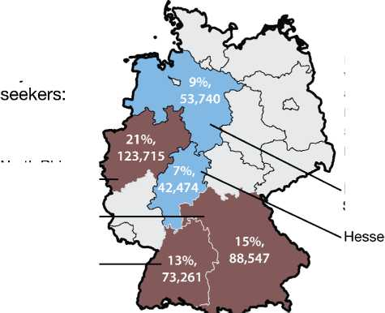

1

Bavaria

Lower

Saxony

Baden-

Wurttemberg

Other Lander were allocated much smaller numbers:

North Rhine-

Westphalia

Using the EASY figures in combination with the number of asylum applications received, on behalf of the Federal Ministry of the Interior, BAMF estimates the number of accommodation places that will be needed annually.

Before the summer of 2015, these calculations had been made mainly on the basis of the asylum application data. This was because the rapidly increasing numbers of refugees in 2015 had resulted in a growing discrepancy between the number of asylum applications and of registrations in EASY.

The differences between the two figures can be significant, for example, on 31 July 2015, BAMF had counted 218,221 asylum applications (firstand subsequent applications) whilst 309,075 people had already registered in EASY.6

A quota - the so-called "Konigsteiner Schlussel" - regulates the distribution of asylum-seekers among the German states, the Lander. This allocates a specific percentage of asylum applicants, based on tax receipts and population numbers, to each of the Lander, which the latter are obliged to accept.7 From January to September 2015, North Rhine-Westphalia, Bavaria and Baden-Wurttemberg registered about 50% of all asylum-seekers recorded in EASY (see Figure 3).

Changes made to the Asylgesetz (German Asylum Law) on 23 October 2015, now requires asylum applicants to stay in their initial reception facility for up to six months (instead of three).8

However, there are no available data on how many people actually live in the reception centres at any one time. This gap in the data became public in early November 2015, when a member of the Green Party requested information on this.9

**Figure 3: Share of selected Lander, respective numbers of registrations10**

From January to September 2015, three Lander were responsible for about

50% of asylum-

Notes: (2) Mitteldeutsche Zeitung (2016) [http://www.mz-web.de/politik/prognose-fuer-2016-weise-rechnet-mit-halber-millionen- fluechtlinge,20642162,33489292.html](http://www.mz-web.de/politik/prognose-fuer-2016-weise-rechnet-mit-halber-millionen-fluechtlinge,20642162,33489292.html). (3) Eurostat (2015) migr_asyappctzm; According to regulation 862/2007 and the methodological note attached to migr_asyappctzm, Member States can submittheir data up to two months after the end of the reference period. Hence, the available data is not complete from November on. The dotted lines reflect this lack of data and the respective trends should therefore be interpreted with cau­tion. (4) BAMF (2016) <http://www.bamf.de/SharedDocs/Meldungen/DE/2016/201610106-asylgeschaeftsstatistik-dezember.html>. (5) BMI (2016) <http://www.bmi.bund.de/SharedDocs/Pressemitteilungen/DE/2016/01/> asylantraege-dezember-2015.html.(6) BAMF (2015) <https://www.bamf.de/SharedDocs/Anlagen/DE/Downloads/lnfothek/DasBAMF/2015-08-20-prognoseschreiben-> asylantraege.pdf. (7) BAMF (2015) <http://www.bamf.de/EN/Migration/AsylFluechtlinge/Asylverfahren/Verteilung/verteilung-node.html>. (8) §47 Asylgesetz (as of 23.12.2015) <https://www.gesetze-im-internet.de/asylvfg_1992/BJ> N R111260992.html.

Germany and the relocation of refugees across the EU

The latest European Commission figures show that the EU's emergency relocation scheme introduced in September 2015, with a target of 160,000 places, is barely functioning yet.

The EU scheme, within which 4,237 places have been made available by 17 EU Member States, has so far only resulted in the relocation of 272 persons. Of these, Germany has made 40 places available, with 11 people relocated from Italy and 10 from Greece.11

In context:

* 4,237 places have been made available in total by 17 EU Member States.
* 190 people have been located from Italy, of a target 39,600.
* 82 people have been relocated from Greece, of a target 66,400.
* 97,982 places remain to be allocated, of an initial 98,256 places.
* 7,744 of the 40,000 decision and 54,000 of the 120,000 decision remain to be allocated.

The EU's Dublin III Regulation, which should facilitate a fair sharing of responsibility among EU Member States has also proven to be slow.12

By the end of November, Germany had made 41,217 'Dublin requests', with peaks in January (4,405, of which 3,117 were based on EURODAC matches) and July (4,839, of which 3,803 were based on EURODAC matches).13 In comparison, throughout 2014, 35,100 requests had been made to other Member States, and around 4,800 people were transferred.14

Germany in the EU: **distribution of asylum applications by main receiving Member States, 2015**

Germany is the main country of destination in Europe for migrants and refugees (see Figure 4). The majority of first time asylum applicants in Germany, in each month since April, were Syrians (see Figure 1, above).

**Figure 4: First time asylum applications in the EU and main five receiving countries, 201515**

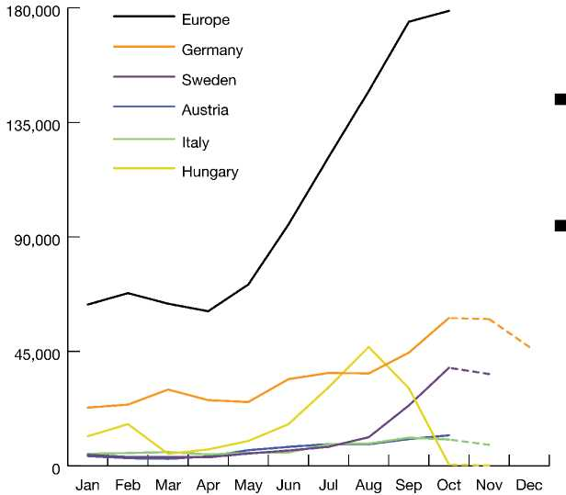These asylum applications take place during the weeks and months after registration.

Final data for October, November and December are not yet available for many EU Member States (see footnote 3).

What is expected in 2016?

The experience of 2015 indicates that caution is needed in estimating future numbers of arrivals. In May 2015, the German Government announced that Germany could expect as many as 400,000 first time asylum applications by the end of 2015, almost double the 2014 figure.16 Only three months later, in August, the official method of estimating the numbers was revised and a figure of 800,000 was then estimated to be the final total of arrivals in 2015.17 This reflected the need to account for a growing disparity between first time asylum applications and arrivals. The final figure was even higher, at one million.

It is possible to say that high numbers of asylum-seekers are likely to continue to arrive in Germany during 2016, but there is no certainty about the precise number of asylum-seekers in Germany (the 'stock') at any one time, let alone how many will arrive - even in the short-medium term.

There is insufficient richness to the data to analyze the characteristics of migrants and refugees, as EASY was not designed as a system to collect and store demographic data: it collects only two variables, namely, "the receiving German state" and "country of origin"; there is a high likelihood of double counting, as around 10 per cent of those registered in EASY do not arrive at their allocated reception facilities and are registered again in another location; and certain groups, such as unaccompanied minors and people placed in detention, are excluded from the figures altogether.

Changes in EU policy have also affected the numbers and are likely to continue to do so, (to what extent, when and how, is not yet known). For example, the European Union and the Western Balkans have selected different groups of countries of origin in their refugee and related border policies. The EU decided on 14th September 2015 that only refugees from Syria, Iraq and Eritrea would be eligible for relocation. This selection of nationalities was based on a 75% recognition rate threshold, based on Eurostat quarterly data for 2014 and 2015.18

Policy and practice in the Western Balkan countries differs from this EU-wide policy, as there are now common refusals at the borders to accept citizenships other than Syria, Afghanistan and Iraq. Added to this are the most recent (as of the 4th of January 2016) re-impositions of border controls inside the Schengen area, by Sweden and Denmark following other (temporary) border controls in Hungary, Austria and Germany in late 2015.19

As such, forecasting the trends in 2016 is problematic. Forecasts provided by BAMF take into consideration the following factors: developments in countries of origin; information from the German institutions dealing with migration issues (the Federal Foreign Office, intelligence services, federal police, liaison staff); the number of asylum applications in Germany as well as in other EU countries, policy responses to migration and finally recent trends and seasonal fluctuations.

It is also likely that the 23 October 2015 designation of Albania, Kosovo and Montenegro as safe countries of origin will affect the future distribution of countries of origin among arrivals to Germany by restricting the numbers of asylum-seekers from these countries. While arrivals from these countries had already been decreasing for a few months, this policy contributed to a further fall in numbers - notably in the arrivals of Albanians.

Notes: (9) Suddeutsche Zeitung (2015) [http://www.sueddeutsche.de/politik/fluechtlinge-bundesregierung-kennt-zahl-der-menschen-in- erstaufnahmeeinrichtungen-nicht-1.2733590](http://www.sueddeutsche.de/politik/fluechtlinge-bundesregierung-kennt-zahl-der-menschen-in-erstaufnahmeeinrichtungen-nicht-1.2733590). (10) See footnote 7; Die Bundesregierung (2015) [http://dipbt.bun- destag.de/dip21/btd/18/068/1806860.pdf](http://dipbt.bun-destag.de/dip21/btd/18/068/1806860.pdf), p.20. (11) European Commission (2016) [http://ec.europa.eu/dgs/home-affairs/what-we- do/policies/european-agenda-migration/press-material/docs/state_of_play_-_relocation_en.pdf](http://ec.europa.eu/dgs/home-affairs/what-we-do/policies/european-agenda-migration/press-material/docs/state_of_play_-_relocation_en.pdf). (12) Fratzke, S. (2015) <http://www.migrationpolicy.org/research/not-adding-fading-promise-europes-dublin-system>, Migration Policy Institute Europe. (13) BAMF (2016) <https://www.bamf.de/SharedDocs/Anlagen/DE/Downloads/lnfothek/Statistik/Asyl/statistik-anlage-teil-4-aktuelle-zahlen-zu-asyl.pdf>. (14) Die Bun­desregierung (2015) <http://dip21.bundestag.de/dip21/btd/18/038/> 1803850.pdf, p. 35. (15) Eurostat (2016) (migr_asyappctzm); see footnote 3. (16) BMI (2015) <http://www.bmi.bund.de/SharedDocs/Pressemitteilungen/DE/2015/05/zahl-der-asylantraege-steigt.html>; EurActiv (2015) [http://www.eu- ractiv.com/](http://www.eu-ractiv.com/) sections/global-europe/germany-expects-number-asylum-seekers-double-2015-314391. (17) BMI (2015) <http://www.bmi.bund.de/SharedDocs/> Kurzmeldungen/DE/2015/08/neue-asylprognose-vorgelegt.html; see also footnote 6.

Integration

Children

The needs of refugee children crossing Europe have been highlighted in the UNICEF/GMDAC Briefing.24 Half of the residence permits granted to Syrians, on the grounds of family reunification, were issued to children.25

Children seeking refuge and unaccompanied minors are an increasing policy concern in Germany. This concern is not alleviated by a lack of transparency in the data and no national level stock figures of the numbers living in the country, nor of those in detention. This is the result both of a lack of Federal co-ordination of the state level data and the absence of information on family ties in the central register of foreigners (Auslanderzentralregister).

Throughout 2015 it became apparent that speedy decision-making on asylum applications was not happening and at the end of December, 364,664 applications were still pending (337,331 of them first time asylum applications) 26

Regulations that oblige asylum-seekers to stay within specific geographical boundaries or cause them to stay in the initial reception facilities for longer time-periods may act as impediments to integration into the German labour market and German society.27

Economic Impact

There has been much discussion of the short-term costs of accepting asylum-seekers. This will be the subject of a separate briefing. It is worth noting that there has been less discussion of the longer-term policy needs and economic potential of immigration. According to the European Commission, the arrival of asylum-seekers has had a positive economic impact on the GDP of EU Member States, with an anticipated average contribution of 0.2—0.3% by 2017.28 This is especially meaningful in high refugee-receiving countries such as Germany Despite increased spending on accommodation and infrastructure for refugees, Germany's budget is expected to remain "in sizeable surplus".

The economic impact, in particular how refugees will affect the German labour market has been extensively discussed in Germany throughout 2015. This debate is often centred around the short-term costs that will inevitably emerge because of the need for integration measures as well as accommodation, education and health care provision.

The German Institute for Economic Research (DIW) has highlighted some positive long-term effects in an article based on simple simulated calculations, suggesting that the immigration of refugees to Germany will positively contribute to the country's economic performance and per capita income.29 These findings are supported by the OECD, which also highlights positive outcomes, including a possible boost in aggregate demand in the EU economy, due to the need for additional expenditure to support asylum-seekers in the short-term.30 Although long-term effects could be positive for both refugees and receiving economies, the realization of this economic potential is intertwined with (and depends on) their integration into society, as well as into the labour market. It may also be dependent on the ability of employers and policy makers to identify where their skills are most needed.

Understanding the data and policy needs for the future

This GMDAC Briefing has outlined what the main data show about the arrivals of migrants and refugees, as well as asylum-seekers in Germany during 2015. The Briefing discusses the rising monthly numbers of arrivals in Germany, it explores the reasons for differences in the numbers which reach the media and public debate. The policy challenges which face Germany and the whole of the EU will require reasoned and responsible use of the data, in order to develop appropriate labour market and integration measures, humanitarian protection, integration measures and importantly provision for children. As the first GMDAC Data Briefing in 2016, it aims to provide a short guide to inform policy, research and analysis. It is hoped that this will help to inform discussion of the policy challenges which lie ahead in 2016.

About

**GMDAC**

In response to growing calls for better data on migration, and better use and presentation of migration data, IOM has created a Global Migration Data Analysis Centre (GMDAC). As a global hub for data and statistics on migration, GMDAC aims to conduct and coordinate research and data projects. Located in the heart of Berlin, Germany, the Centre aims to provide authoritative and timely analysis of data on global migration issues.

**Data Briefing Series**

The GMDAC Data Briefing Series aims to explain what lies behind the numbers and the data used in migration policy and public debates. The Briefings explain what 'the numbers' really tell us about movements of migrants, refugees and asylum-seekers, on a range of topics for policy, across the globe.

The way the data are presented has an important influence on public perceptions of migration in Europe and on the development of policy. The Series will serve to clarify, explain and exchange specialist knowledge in an accessible format for wider public and policy audiences, for capacity-building and evidence for policy. Briefings will be of interest to expert as well as lay audiences, including journalists, students, local authority and city planners and lawyers.

Contact information

For more information about the Data Briefing Series please contact the editors:

Frank Laczko, Head of GMDAC

Tel: +49 30 278 778 23

Email: [flaczko@iom.int](mailto:flaczko@iom.int)

Ann Singleton, on secondment to GMDAC University of Bristol

Email: [ann.singleton@bristol.ac.uk](mailto:ann.singleton@bristol.ac.uk)

Global Migration Data Analysis Centre (GMDAC) International Organization for Migration (IOM) Taubenstr. 20-22 D-10117 Berlin, Germany

Tel.: +49 30 278 778 22 Fax: +49 30 278 778 99

Please visit the GMDAC website for publications, resources, and events: <http://gmdac.iom.int>